OpenShift Container Platform is a Kubernetes environment for managing the lifecycle of container-based applications and their dependencies on various computing platforms, such as bare metal, virtualized, on-premise, and in cloud.

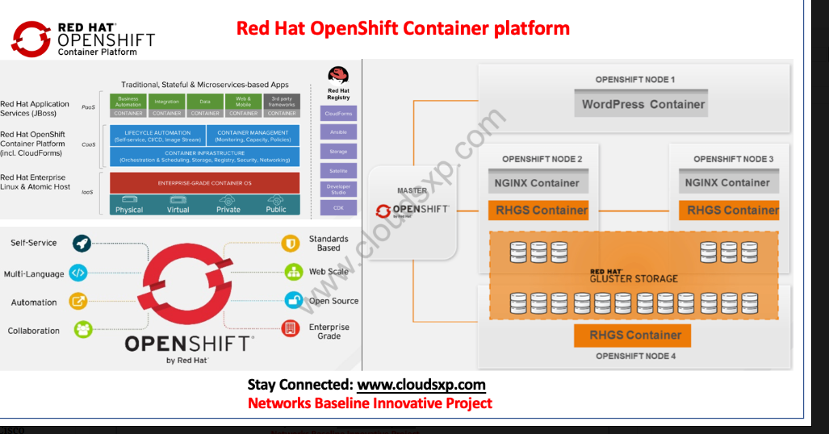

**What are containers?**

* Containers are executable software packages that include everything needed to run an application
* Containers are intended to be stateless and immutable
* Containers decouple applications from the underlying host infrastructure

**What does Kubernetes do?**

* Kubernetes automates the deployment, scaling, and management of containerized applications
* Kubernetes handles the compute, networking, and storage for your workloads
* Kubernetes monitors your applications and restarts containers that fail
* Kubernetes automatically places containers based on their resource requirements

What are the benefits of Kubernetes?

* Kubernetes makes it easier to manage applications
* Kubernetes allows developers to focus on applications and not worry about the underlying environment
* Kubernetes offers a logical packaging mechanism, reducing the gap between what is developed and what is deployed